JetMach Sport 60

Aerobatic sport airplane for small (14 lb) thrust turbines

Wing Span 80 In
Wing Area 1300 Sq In
Weight (dry) 16.5 Ib

Fuselage length 75”
Two piece wing
Uses standard servos.

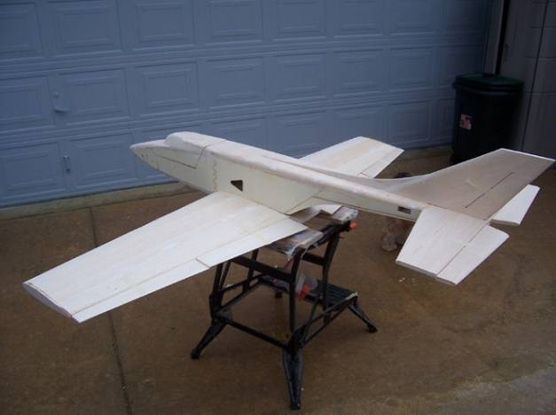

Warranty…… Laser Design Services L.L.C. guarantees this kit to be free of defects in both material and workmanship at the date of purchase. This warranty does not cover any component parts damaged by use or modification. In no case shall Laser Design Services L.L.C.’s liability exceed the original cost of the purchased kit. Further Laser Design Services L.L.C. reserves the right to change or modify this warranty without notice.
In that Laser Design Services L.L.C. has no control over the final assembly or material used for final assembly, no liability shall be assumed nor accepted for any damage resulting from the use by the user of the final user-assembled product. By the act of using the user-assembled product the user accepts all resulting liability.
If the buyer is not prepared to accept the liability associated with the use of this product, the buyer is advised to immediately return the kit in new and unused condition to the place of purchase.

Safety Precautions

This radio controlled model is not a toy.

Experienced modelers should have no
difficulty during the construction and flying of this JetMach design.

Construction and flying of this model is not recommended for beginners.

Turbine powered models are for advanced flyers only.

READ THROUGH THIS INSTRUCTION BOOK FIRST, BEFORE BEGINNING ASSEMBLY.

A construction photo CD is included.

Recommended Hardware List

Tower Hobbies part number are given for reference, note that the package may contain more parts than you will need. Check your local hobby store.
Feel free to substitute hardware as you see fit.

Tower part # | Hardware | Quantity per plane
G.P. LXK196 | Nylon boltsx4 | 4
LXD866 | Pushrod Cover | 1
LXE007 | 1/4-20 Cap screw | 2
G.P. lxk079 | 4-40 Clevis | 6
G.P. lxk085 | 4-40 clevis solder | 6
Ex: robart LXET42 or use fiberglass horn | Control horn Ail/el | 4
Ex: Robart LXET43 or use fiberglass horn | Control horn Flap | 2
Dubro LXD802 | 4-40 pushrod 12" | 6
Rudder control rod and clevis
Dubro lxd972 or drill and tap wing mount blocks | 1/4-20-blind-nuts | 6
Aileron and flap control horn bolts (if required) | 2-56 x 1.25 | 12
G.P. LXK110 | CA hinge(24) | 24

50 Oz tank
3” main wheels with brakes
2” nose wheel
UAT (or make your own)
Hatch Latch

JetMach Sport 60 Assembly Instructions

Use suitable glue, I use aliphatic wood glue ("Titebond" carpenters glue) for most every thing, it adheres to plywood the best. You have to wait for it to dry though, or use thin and thick C.A.

Foaming polyethylene (Gorilla glue) can be used for the wing blocks . Silicon glue is used for the heat shield.

Cover the plans with wax paper to protect them when gluing.

Make sure you have a flat surface, weights, T-pins and clamps with at least a 6” capability available and the glue

Place a check mark at each construction point as you build.

Remove the parts from the laser cut sheets and bag the like parts. Note that some wood has been left to secure the parts in place, Use a sharp blade to free the parts where necessary.

Note: test fit all parts before gluing

On a Flat work surface:

Wing Assembly

Note, I used aliphatic glue for the wing assembly.

Right Wing

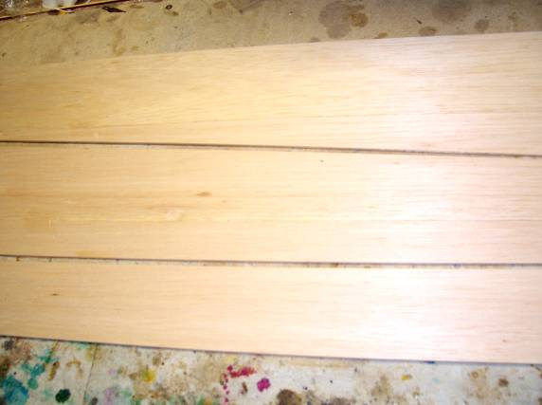
Wing sheeting.

Glue pieces of the 3/32 sheeting together as required, make sure that the edges are straight, lay on a wax paper covered flat surface and tape together using masking tape, flip over, fold the sheet towards the masking tape, run a bead of aliphatic glue along the join, fold back together, wipe off the excess glue and pin down, repeat for each wing. Sections can be stacked with wax paper between each.

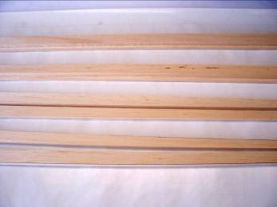
Wing leading edge

Laminate ribs 1 and 1-a and 1-1 and 1-1a, making sure that they are aligned.

Laminate the wing bolt mount plates, four sets; laminate the wing tube support doublers and the gear mount doublers to ribs 2 to 5, note that the wing tube support doublers are not symmetrical. Laminate the main gear supports and main gear mounts. Make a right and left hand sets

Clean any glue residue from the wing tube holes and wing bolt mount holes, and trial fit the wing tube, and the wing bolt mounts in their slots.
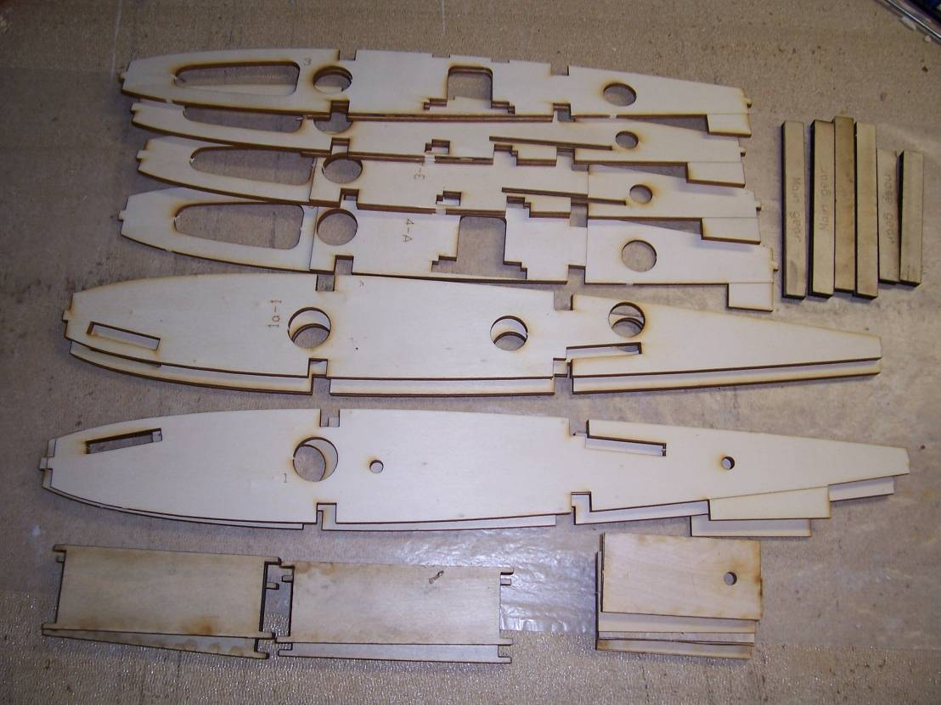
Laminated ribs.

On a flat surface, cover the plans with wax paper, cut to length and pin the 3/8 sq spar to the plan, ensure that the spar is straight and aligned on the plans.
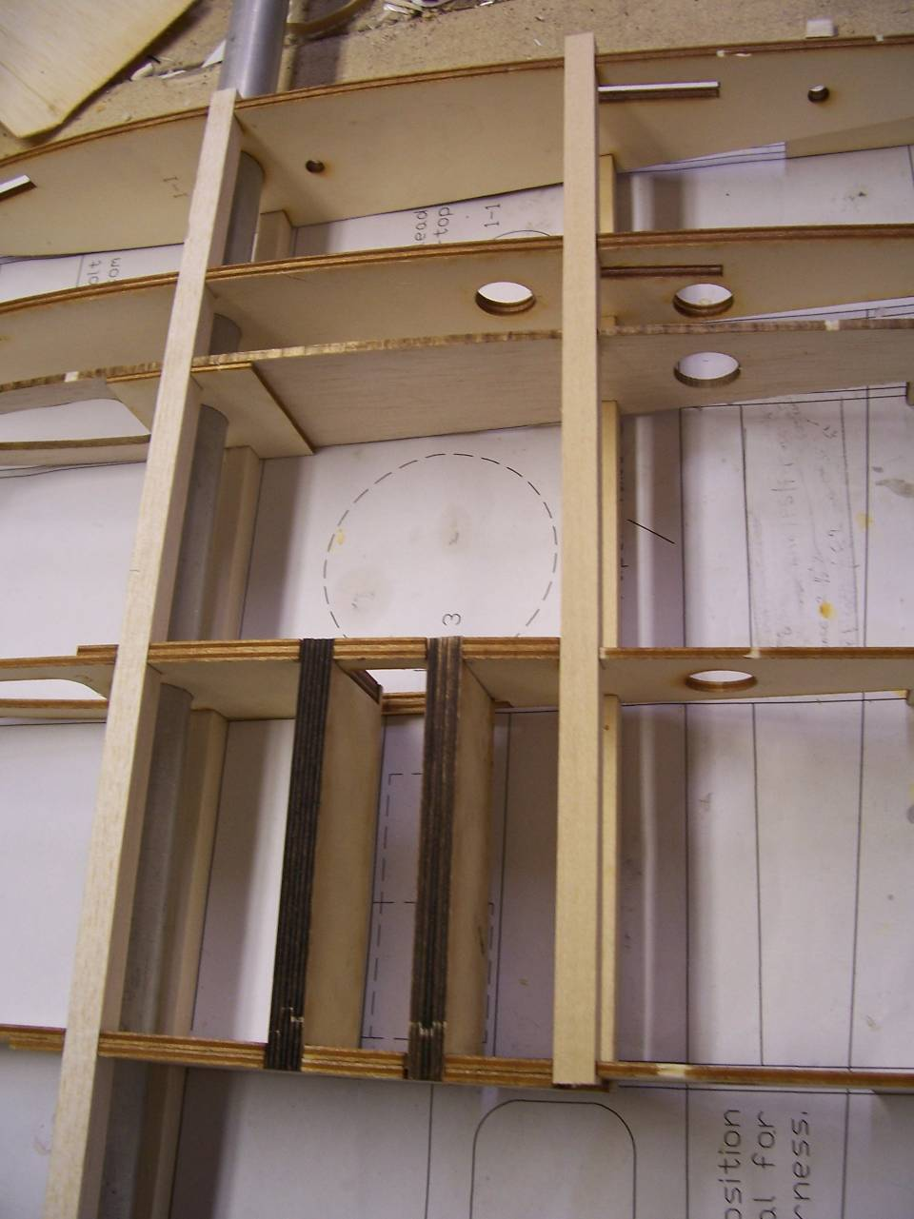
Wing assembly.
.

Locate the dihedral alignment gage. Note that the top of the wing is flat when both sides are assembled upside down and the rib taper will result in a positive dihedral.

Position the ribs on the plan with the tabs down.

Glue rib #1 to the spar; align with the dihedral gage with the arrow pointing up.

Glue the rest of the ribs to the spar in place over the plan, making sure that the ribs are aligned and vertical and the rib tabs are in contact with the plan.

Fit the wing tube and leave in place.

Insert and glue in place the laminated main gear support plate

Cut the top spar to length and glue in place; make sure that the dihedral angle is set.
.
CA Glue the laser cut 1/8 trailing edge and leading edge to the ribs, ribs are tabbed to fit into the leading and trailing edge of the ribs.

Glue the 3/8” sq basswood spars in place.

Glue the 1/4 in trailing edge in place, sand even with the 1/8 trailing edge.

Glue the wing mount plate with epoxy, in the slots in Ribs1 and 1-1; note the location of the wing mount holes.

Glue the main gear supports in place with epoxy

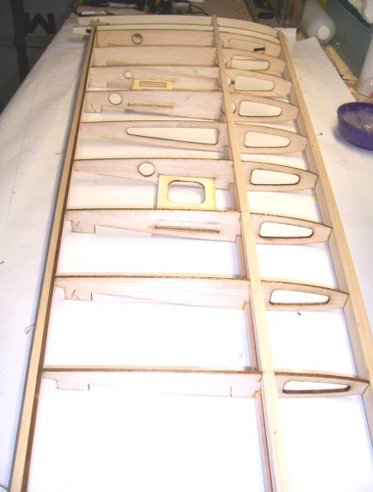 Wing assembly

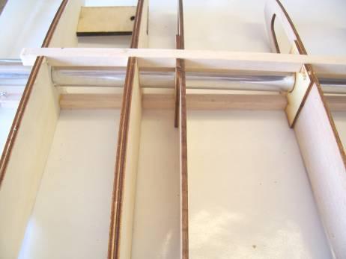 Wing tube fit.

Cut the shear webs from 3/32 sheet and glue the shear webs in place between ribs1 and 9 and to the rear of the basswood spar, the shear webs are even with the top of wing spars, the grain of the shear webs must be vertical
Let dry completely.

Roll and Install a paper tube thru the holes in the ribs for the servo wires, tack glue in place
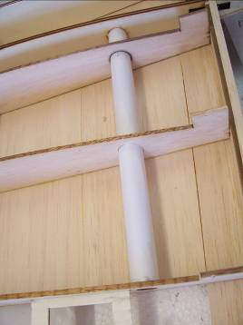 paper tube

Cut and glue 1/4 scrap to fill the gap between the wing mount plates and the top of the rib at the location of the wing mount holes. Sand the balsa to conform to the rib this is required to resist the force exerted by the wing bolts

Sheet the top of the wing, starting at the main spar, forward to the leading edge, the rear of the sheeting should align with the middle of the top spar, glue sheeting to the main spar,ribs and to the leading edge,. Note: that spraying the top surface sheeting with water will aid in curving the sheeting. Sheet the rest of the wing. When dry trim the sheet leading and trailing edges

Drill through the wing mount holes perpendicular to the wing mount plates, and the top sheeting to locate the wing mount holes

Let the glue dry completely, and then turn the wing over to work on the bottom.

Remove the wing rib tabs. Glue the root and wing tip tabs to the top sheeting at the same location, to ensure wing is straight when sheeting the lower surface

Sand the ¼ in trailing edge even with the 1/8 trailing edge.

To ensure the correct wing incidence, pin the trailing edge and spar securely to the plans

With the following step the wing will start to become rigid, make sure the wing is held securely to the plans.

Position the bottom leading edge sheeting in place, the rear of the sheeting should align with the middle of the top spar, glue sheeting to the main spar, ribs and to the leading edge.

Glue the liteply servo mounts in the slots in the ribs, orientate as per the plans, and add the reinforcing doublers where servo screws are located.

Glue the main gear mounts to the ribs and main gear support with epoxy.

Run pieces of string to the servo locations from the wing root

Sheet the rest of the wing, as the sheeting is progressing, mark the positions of the servo mount openings and the main gear mount.

When dry trim the sheet leading and trailing edges.

Glue the laminated 1/4 in leading edge to the ribs and 1/8 leading edge even with the top and bottom sheeting

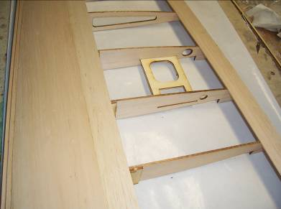

Drill the wing mount holes through the bottom sheeting, enlarge the wing mount holes in the bottom sheeting to 1 in dia to accept the wing bolts, make a paper tube to fit in the holes to restrain the wing bolts

Round the leading edge to an airfoil shape, refer to the plans for the correct shape; sand the wing sheeting, wing tips etc. Cut out the servo mount openings and the servo wire, brakes and retract tubing access hole in the top of the wing.

Put the wing aside and build the left wing following the above instructions.

Wing alignment

Glue a ¼ in locating dowel in the alignment hole in one of the wing root ribs

Flaps and Ailerons

Pin the 3/32 flap and aileron pieces to the plans. Sand the ¼ in leading edge pieces at an angle as shown on the aileron/flap section drawing. Glue the leading edge in place, using the sub ribs to set the correct angle, glue the flap/aileron sub ribs in place.

Glue scrap ¼ in pieces for the control arm, as shown.

Sand leading edge level with ribs

Glue the top 3/32 aileron/flap pieces.

Sand the top trailing edge flat. Sand ends to the size shown on the plans and add 1/8 sheet caps to close surfaces.

Verify the alignment and thickness of the flap/ailerons, to the wing and sand as required.

Ailerons sand the top and bottom surface smooth, round the rear edge, sand and plane a 30 Deg bevel to the leading edges.

Flaps are hinged at the bottom surface and must have a small gap when in the up or neutral position to eliminate any servo stalling in the up position, sand as required.

Fuselage
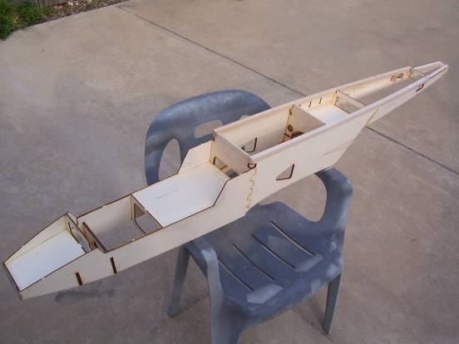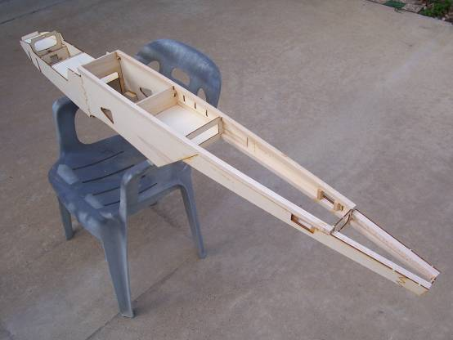

Laminate: clamp each piece until dry.

F-4's
F-5's
Nose wheel formers
Engine mounts

Make sure that you make a right and left hand fuselage side,

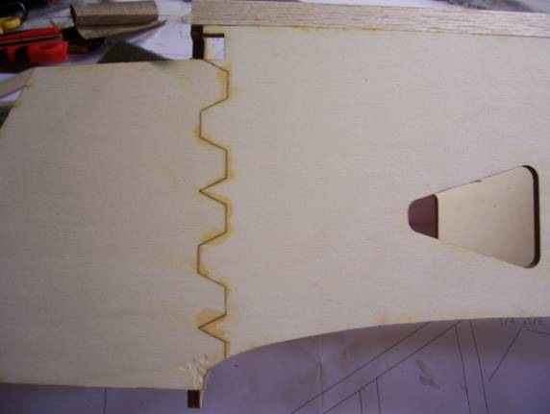 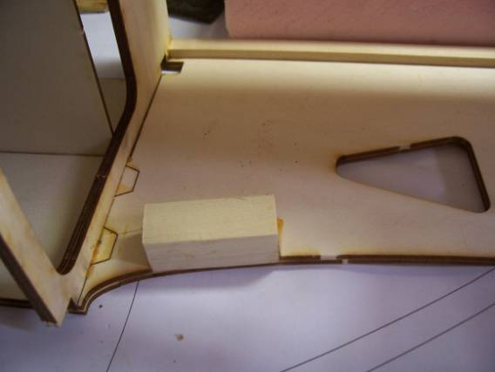Fuselage joint

On wax paper, glue each of the side 1 joints together, ,, place a piece of saran wrap between the two sides at the joints, make sure both are aligned the same and weight them down on a flat surface to dry.
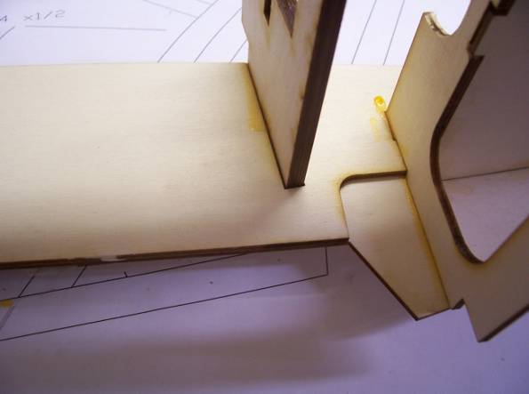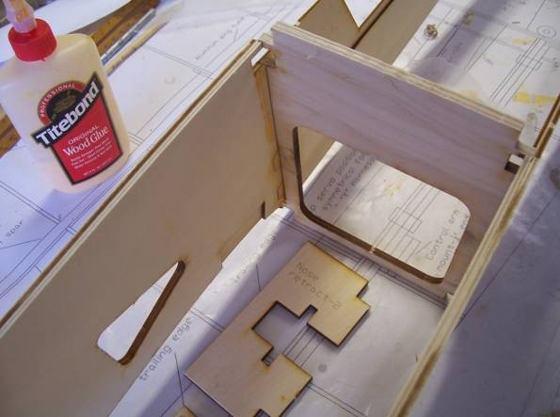

Lay one glued side 1 on a flat surface, align the side 2 doublers, align the doublers using the triangular air inlet as a guide and glue in place, weigh down, when dry, flip over, and build the second side on top of the first, this will ensure a left and right hand side. (Fig 1) and the side alignment, or build them side by side.

Lay a completed side on a flat surface, slot and glue F-4 and F-5 in place, place the other side on top, glue and slot in place. Make sure formers are perpendicular to the sides. To ensure fuselage alignment, place the fuselage upside down on a flat surface, resting on the wing opening, clamp the sides together and weight down and let dry.
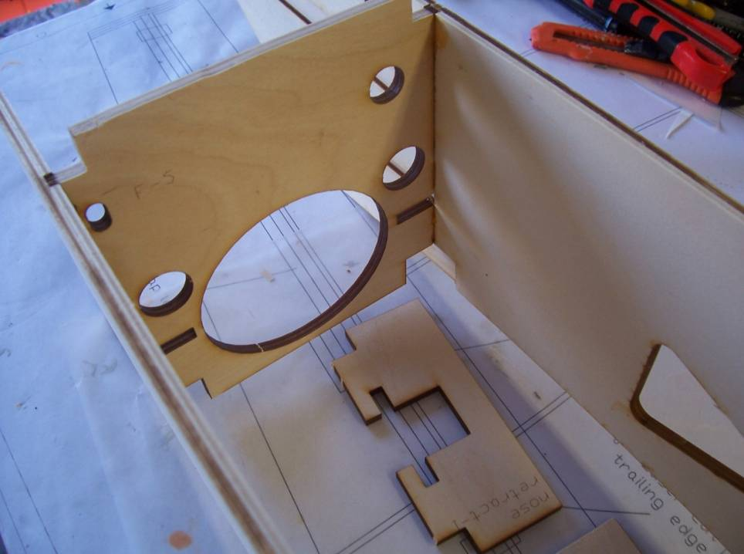

Lay the fuselage on top, glue "rear fuse bottom" in place (Fig 3), IMPORTANT. Make sure it is seated on the lower edge of the fuse doublers and even/flush with the rear of F-5, this is essential for the alignment of the rear fuselage. Clamp the rear of the fuselage to conform to the "rear fuse bottom".
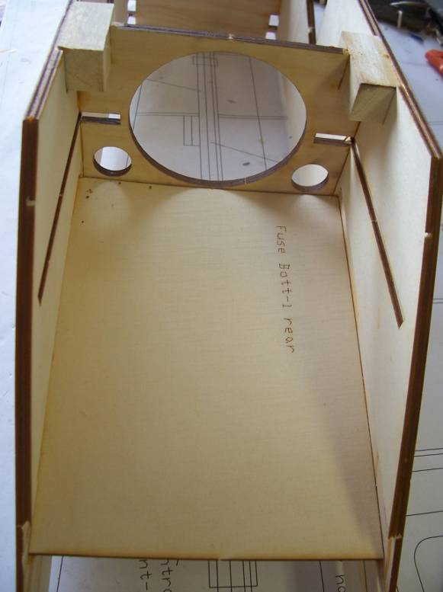

Glue engine mounts in slots in F-5 and fuse doublers, arrow points to fuse outer side
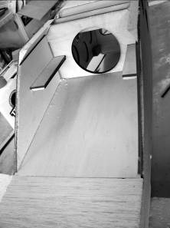

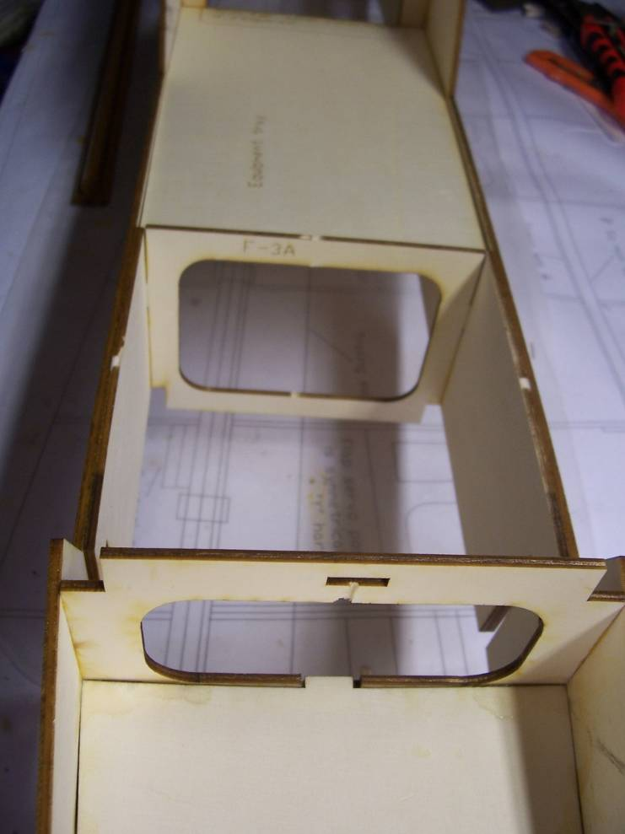

Trial fit F-3 and the equipment tray; this will ensure the forward fuselage alignment.

Glue F-3, with the equipment tray in place; do not glue the equipment tray. (Fig 4)

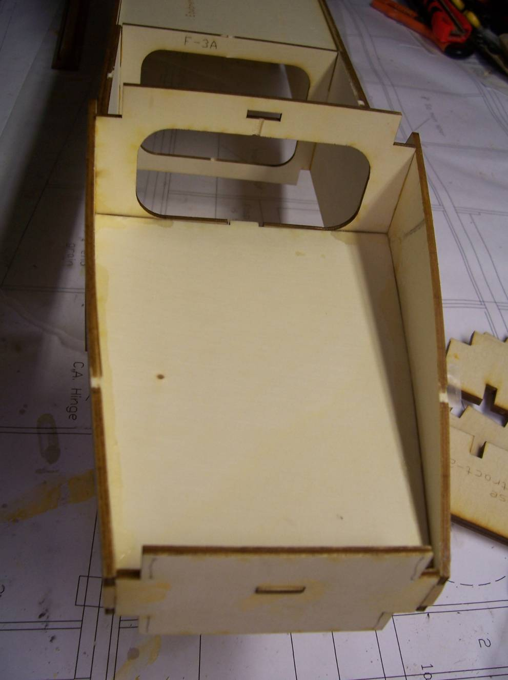

Install and glue F-1 and F-2, using the battery compartment floor for alignment

Install the nose gear mounts into the slots on the fuselage

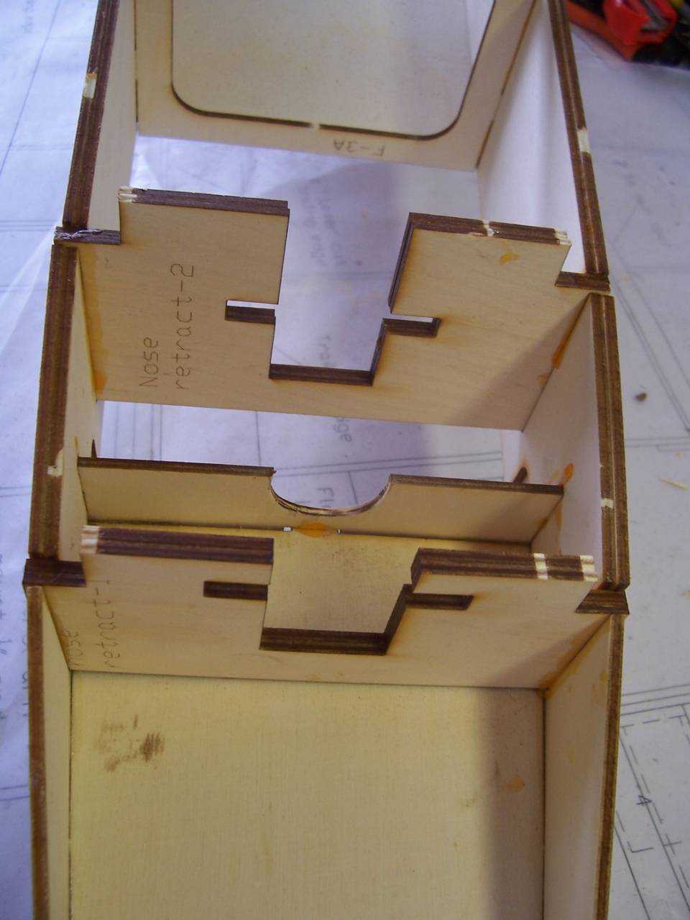
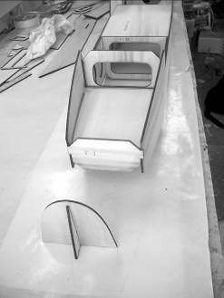

View fuselage from front to check alignment, when satisfied; glue the battery compartment floor in place.

Glue the nose formers together, glue assembly to F-1.

Rear fuselage

Make a right and left hand side

A set of sides made of lite-ply are provided. Laminate the servo opening reinforcing pieces and modify the square stock to fit.

Cut the 1/2 in square strip, two pieces ", two pieces 33", and two pieces 8.5”.

Join the two parts of each rear fuselage side piece, together

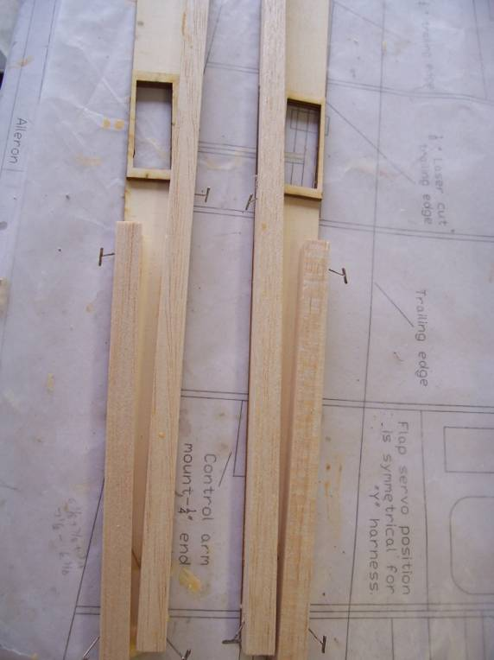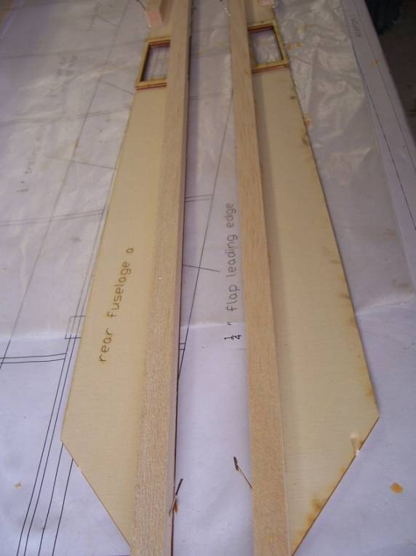
Glue the square pieces to the rear fuselage sides (the 33” piece to the bottom edge, ensure the square stock is even with the rear fuselage sides. Pin to a flat surface

Sand the stabilizer mount area flat.

Place the forward fuselage on its top slide the two rear fuselage pieces in place to check the fit, the bottom square stock is flush with the “rear fuselage bottom", overlap joint must be aligned with no gap.

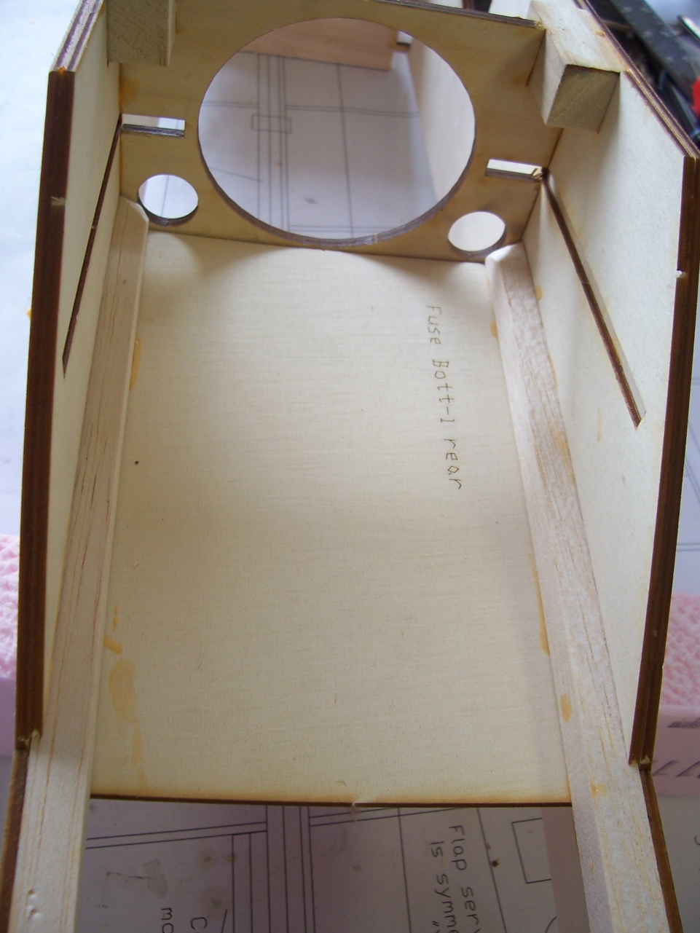

Locate F-8 in place and rubber band the rear of the fuselage to hold fuselage sides together.
This will ensure the alignment of the rear fuselage.
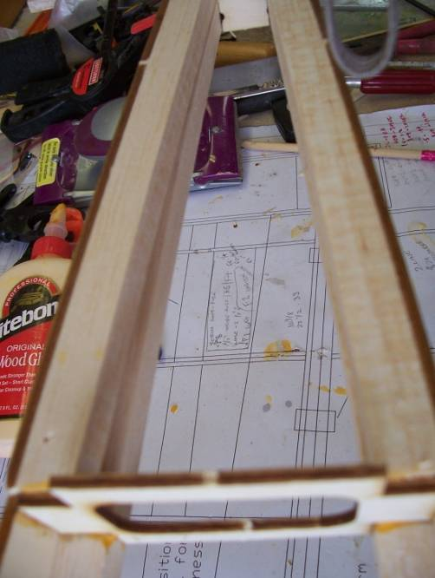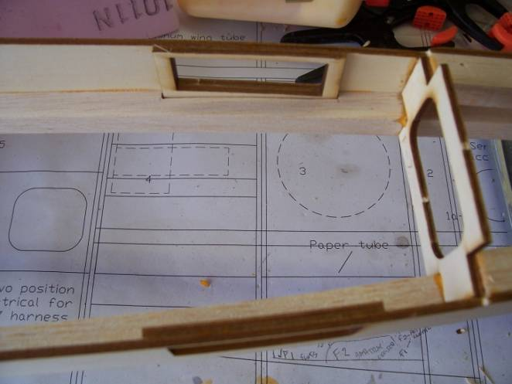
Pin in place and view fuselage from the front, place a straight piece of wood across the rear stabilizer location and check that it is horizontal. When satisfied with the alignment, glue the front of the rear fuselage securely in place with aliphatic glue or C.A. to the fuse sides, and the “rear fuselage bottom”

Glue F-8

Glue F-6 at the rear of the "rear fuselage bottom" and to the fuselage sides.

Glue F-7 in front of the horizontal stabilizer location.

Make servo mount blocks out of 3/8 sq basswood and glue to servo doublers and the ½ in Sq strip
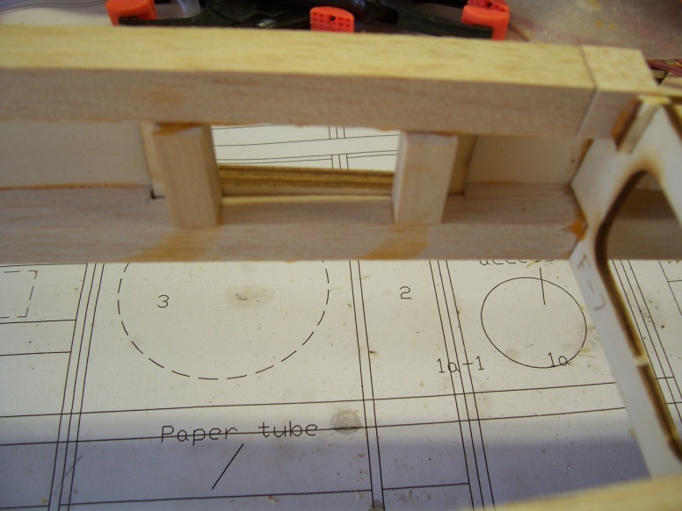
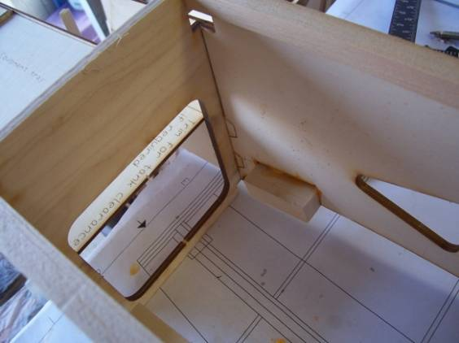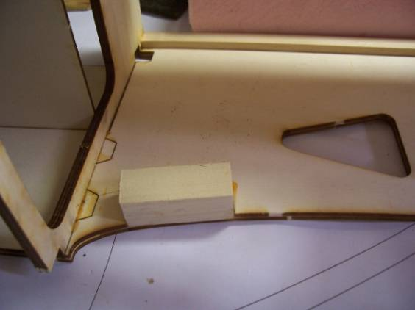

Wing Mount Blocks

Glue and clamp the wing blocks and doublers to the fuselage sides securely, use foaming polyurethane glue or slow cure epoxy, the bottom of the wing block is level with bottom of the fuselage sides.

Hatch

Make a right and left side.

Glue bottom strips to the lower edge of the hatch sides.

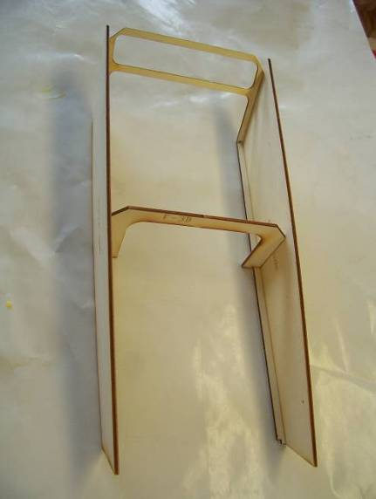

Mark the position of F-3 on the hatch sides, glue F-3 and rear hatch former to hatch sides,

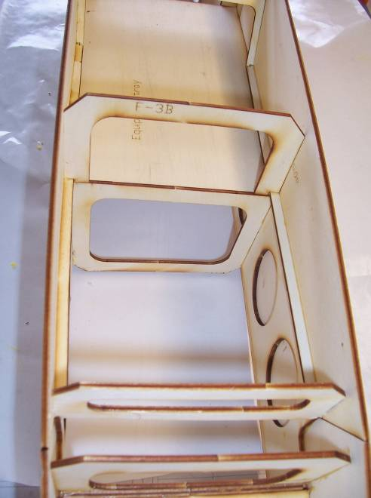

Locate the hatch on the fuselage. Adjust the width of front hatch former if necessary to ensure that the hatch is flush with the fuselage sides and glue the front hatch former to the hatch sides.
Note: parts are included for a hatch tongue, align tongue with the slot in F-2 and glue the tongue support to the front of the hatch

Tape the hatch in position on the fuselage, flush with fuselage sides.

Fuselage

Cut the 1/2 in square stock to length, from F-4 to F-1, glue to fuselage, hatch and formers, both sides.
Note: If necessary, to ease the bending of the strips, cut slots into the strips on the inside of the curve with a small saw

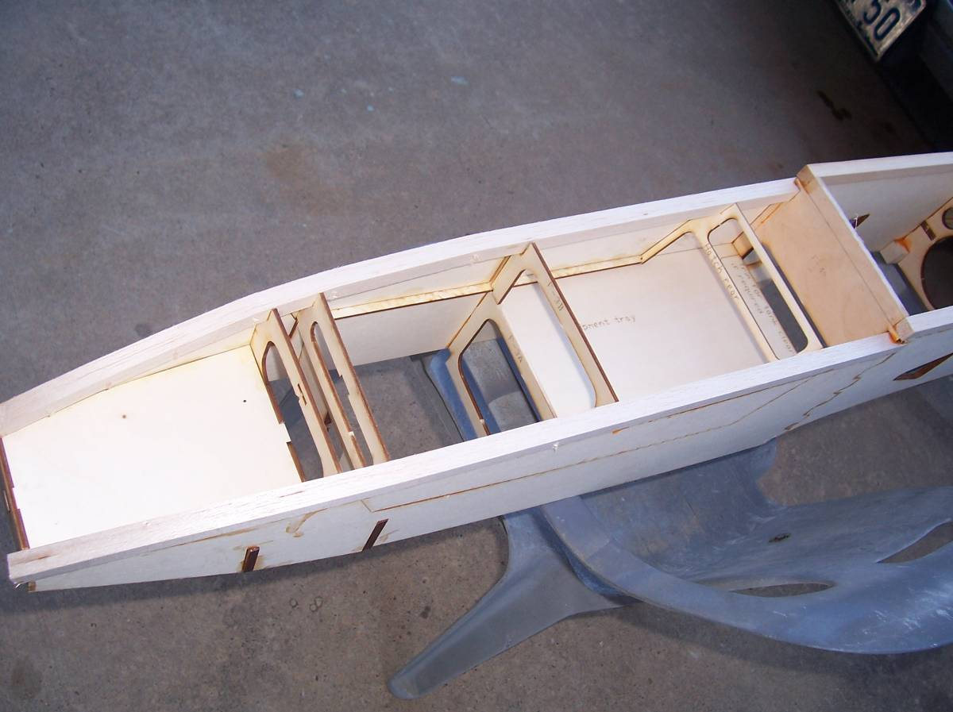

Cut the 1/2 in square stock to length, from wing opening to the end of the fuselage, glue to fuselage, and formers, both sides.

Sand the square strips flush with fuselage sides.

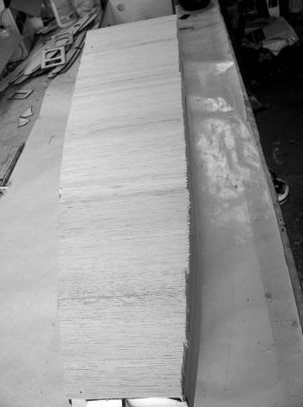

Glue the 1/8 sheet "cross grain" to the to fuselage top.

Parts are included for a canopy. Glue to the fuselage in front of the step and create a shape you like. Or fair the step into the forward fuselage and add a canopy of choice.

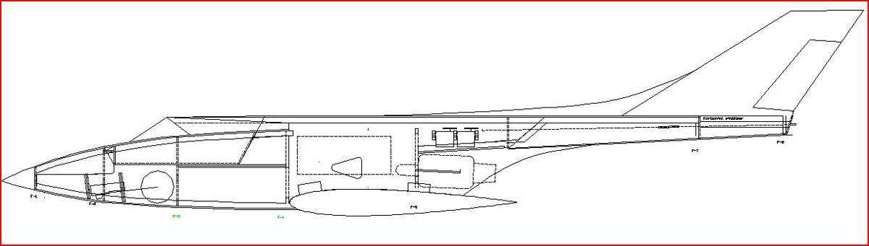

Glue the 1/8 sheet "cross grain" to the to fuselage bottom from the wing opening forward.

Install the rudder servo mount as shown

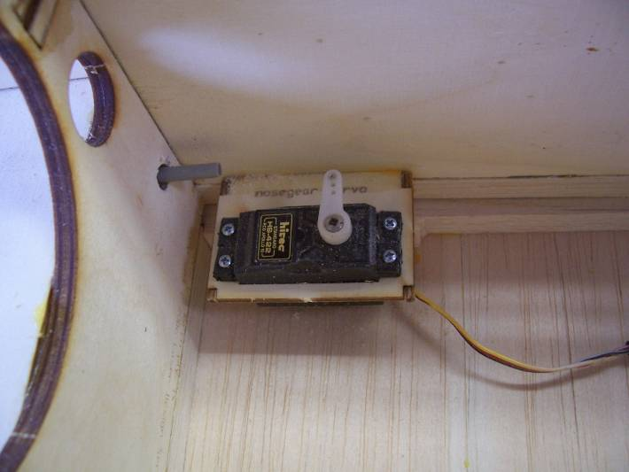

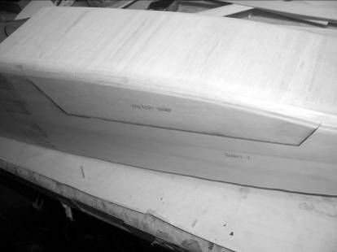

Sand the corners of the fuselage to a round section. A sanding block with 60 grit will get the job done...

Using a hard backed razor blade or thin saw, cut the hatch free from the square stock and the 1/8 sheet.

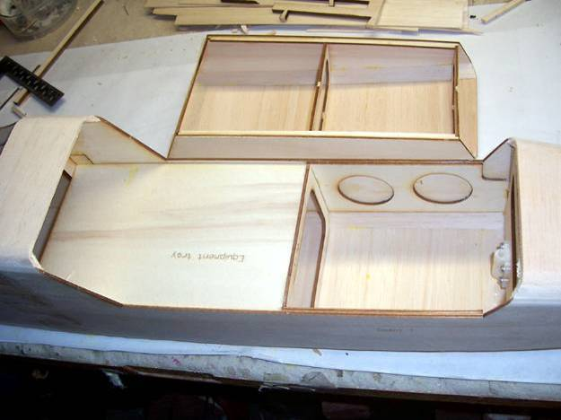

Sand front and rear of hatch.

Glue the hatch location tabs to the rear of the hatch.

Install the rear hatch retaining latch, made or purchased, make the latch pin retaining block from scrap lite ply and glue to the hatch rear. Drill to suit.

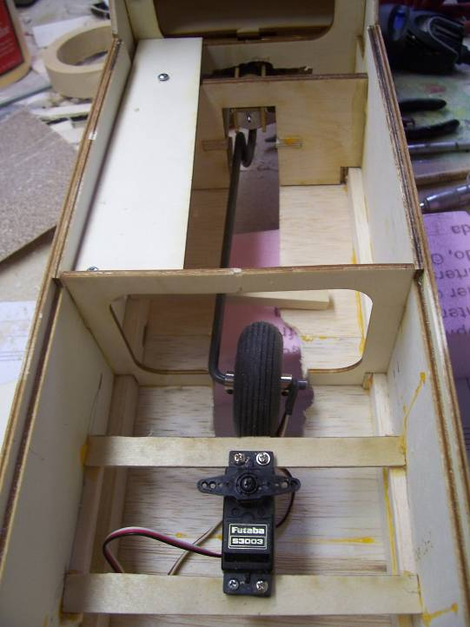
Place the Rx here

Cut the battery switch and air system inflator tray mounts from basswood, and glue to the right or left fuselage side (Left side shown).

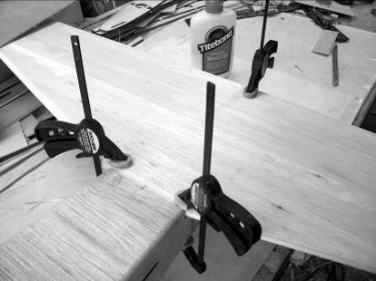

Horizontal Stabilizer

Laminate the 1/8 balsa stabilizer parts

Cut two sets of the 1/8 sheet to the shape of the stabilizer using the plans as a guide, glue the three pieces together.

On a flat surface

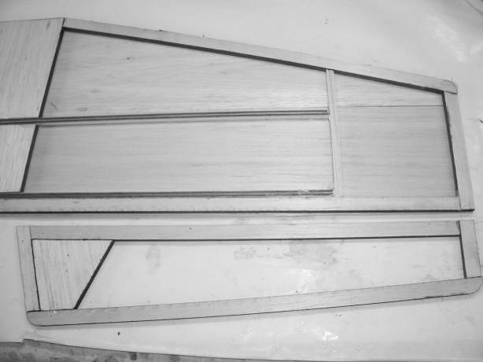

Cut the 48in 1/4in Sq basswood stick into two 24in parts.

Pin the 1/4in Sq basswood to the plans, cut the 1/4 x 1/2in and 1/4in Sq balsa for the stab using the plans as a guide, pin and the parts to the plan and glue. Pin and glue the 1/8 sheet to the stab parts on the plan, weigh down and let dry.

Glue the other 1/8 sheet to the other side. Weight down and let dry. (Fig 13)

Cut the slot on the horizontal stabilizer. Sand the top and bottom surface smooth, sand the rear edge flat, round the leading edges

Elevators

Laminate the 1/8 balsa elevator parts

Cut the 1/4 x 1/2in balsa for the elevator using the plans as a guide, pin and glue the parts to the plan.

Pin and glue the 1/8 sheet to the elevator parts on the plan, weigh down and let dry. Glue the 1/8 sheet to the other side, weigh down and let dry.

Sand the top and bottom surface smooth, round the rear edge, sand or plane a 30 Deg bevel to the leading edges.

Vertical Stabilizer

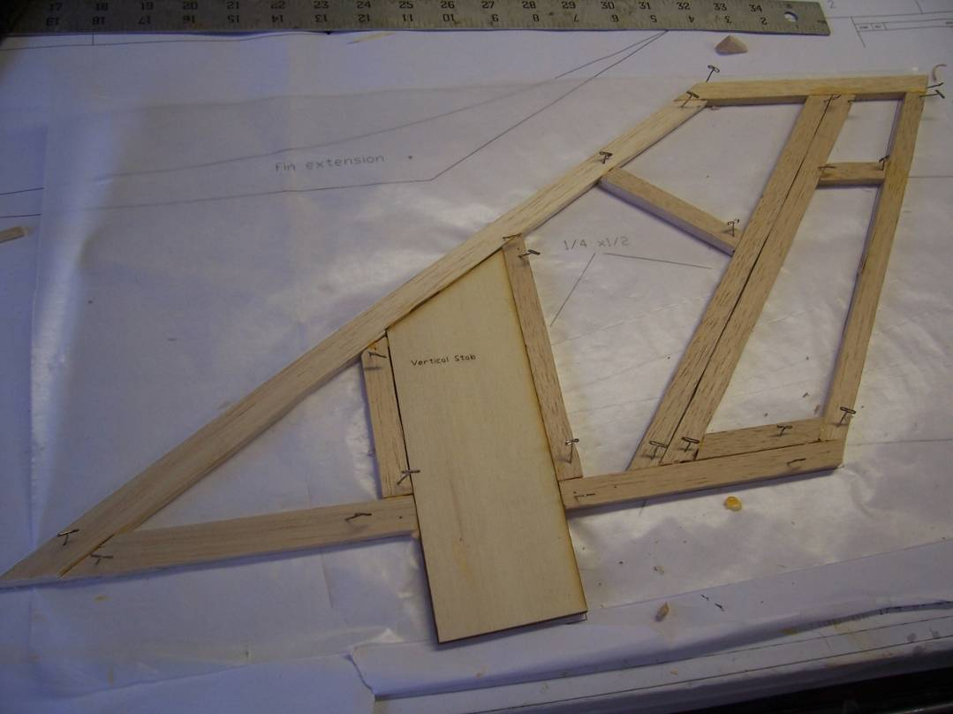

Cut two sets of the 1/8 sheet to the shape of the stabilizer using the plans as a guide, glue the two pieces together

Cut the 1/4 x 1/2in and 1/4in Sq balsa for the stab using the plans as a guide, pin and glue the parts to the plan. Pin and glue the 1/8 sheet to the stab parts on the plan, weigh down and let dry.

Glue the other 1/8 sheet to the other side. Weight down and let dry. (Fig 14)

Cut the rudder loose from the vertical stab.

Vertical stab-Sand the top and bottom surface smooth, sand the rear edge flat, round the leading edge

Rudder-Sand the top and bottom surface smooth, round rear edge, sand or plane a 30 Deg bevel to the leading edge.

Open the slot in the rudder for the push pull rudder arm and test fit the arm in place.

Horizontal Stab

Sand the horizontal stab mount on the fuselage to remove any glue residue, etc.

Place the horizontal stab in place, trim the leading edge, if necessary, such that the rear of the stabilizer is in line with the rear of the fuselage and pin in place.

Lay the vertical stabilizer on top of the horizontal stab with the laminated birch ply through the slot in the horizontal stabilizer. The birch ply will be glued to the bottom of the fuselage at a later stage.

Slide the vertical stab through the horizontal stab; test fit the vertical stab retainer on the bottom of the fuselage. Remove the vertical stabilizer.

Horizontal/Vertical tail Assembly

Align the horizontal stab by measuring from the front of the fuselage to the rear corners of the stab, the distances must be equal, pin in place and mark the stab position, verify that the stab is horizontal to the fuselage.

Remove and glue stab to fuselage, using epoxy, I used 30 min mixed with milled fiberglass. Verify alignment and horizontal position.

Position the vertical fin in place, verify that the fin is flush with the horizontal stab and fuselage and aligned with the centerline of the fuselage.

Glue the fin in place, ensure that the fin is 90 Deg to the horizontal stab and aligned with the centerline of the fuselage when dry, and securely glue the vertical stabilizer tongue and the vertical stab retainer to the bottom of the fuselage.

Laminate the two fin extensions and glue to the top of the fuselage and the fin. When dry, smooth extension fin junction with lightweight wood filler.

Nose
Glue the two nose pieces together and glue to F1. To shape the nose fill the space between the formers. I use blue or white foam, sand to shape and fiberglass the nose.
Scrap ¼ in balsa can also be used, shape to fit.

Fuselage

Position the rudder servo in place, run the rudder control rod and plastic tube to exit the top of the fuselage, just in front of the horizontal stab. Glue the plastic tube in place, remove the control rod and trim the tubing flush with the fuselage top.
Note: Run string from the elevator servo locations to the middle of the fuselage.

Glue 1/8 sheet cross grain to the bottom of the rear fuselage, sand edges, do not round.

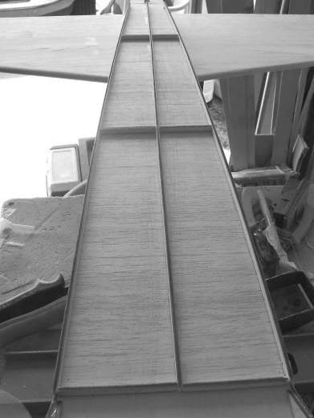

Glue the 1/4 x 1/8, (1/4 in vertical). Sticks to the bottom of the fuselage in the pattern shown, this is the mount for the aluminum heat shielding.

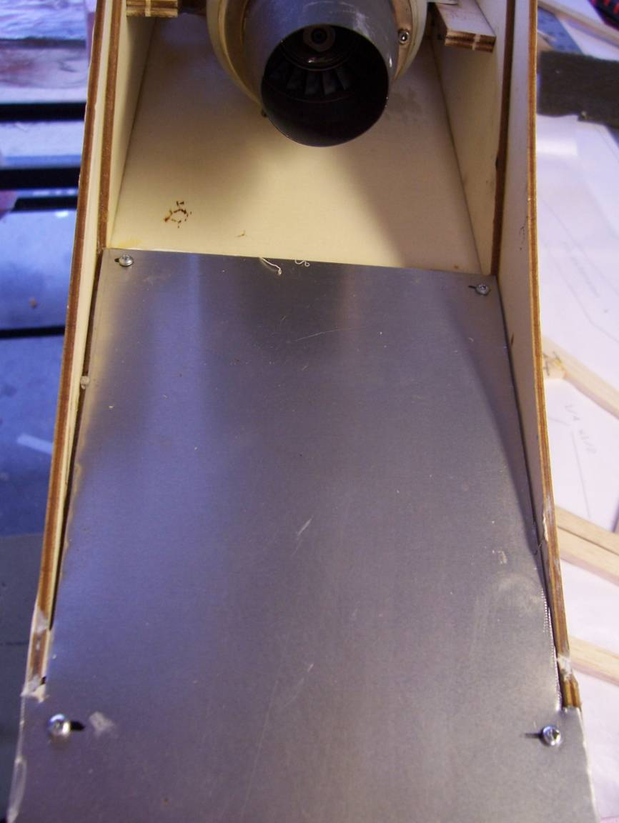

Wing Assembly

Place the assembled wing in place on the fuselage, trim the leading edge at the center to fit in the wing saddle if necessary, mark the center of the fuselage, front and back and align the wing centerline to the marks. Measure from each wing tip to the horizontal stabilizer and ensure that the measurements are equal, tape or pin in place, verify that the wing is aligned horizontally, adjust the wing saddle as necessary.

When satisfied with the alignment, mark the wing mount holes on the wing mount blocks, drill with 1/4 in bit through the holes in the mounting plates to mark the wing mount blocks, do not drill through the blocks, drill and tap for ¼-20 or enlarge the holes in the wing mount block to accept the t-nuts, install t-nuts.

Place a piece of Saran wrap around the leading edge of the wing at the center, mount wing with the four nylon bolts, verify wing alignment.
Fill in the gap between the wing and the fuselage with scrap balsa if required, gluing the balsa to the fuselage.

Remove wing.

Cut a hole in the top of the wing, 7in from the rear of the wing and 1.5 in from the wing root for the servo wires on each side.

Use the previously installed thread to the flap and aileron servos, to pull through the servo cables.

Make equipment tray support brackets from scrap basswood and glue to the fuselage sides, install equipment tray

Make supports for the nose gear servo, Install the nose gear steering servo underneath the equipment tray and connect the servo to the nose gear steering arm with pull-pull cables...

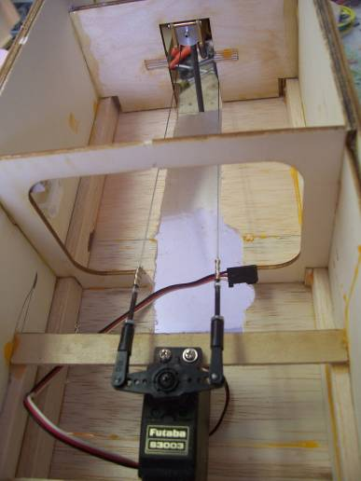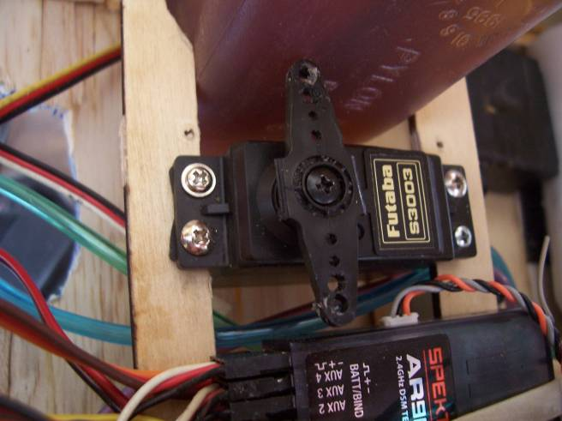

Using the previously installed thread/string, run the elevator servo extension wires (I prefer to solder all my extensions directly)

Install the elevator and rudder servos as shown.

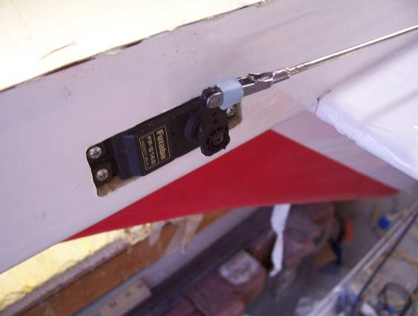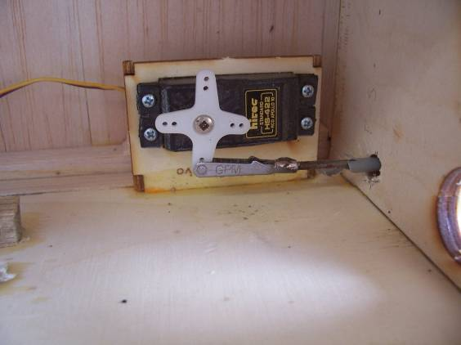

Slot the ailerons, flaps, elevators and rudder for the C.A. hinges as shown on the plans

Drill the servo mounting holes for the aileron and flap servos, run CA into the holes

Cover the airframe, I used Monokote. Note: do not cover the heat shield area.

Note: to remove the covering material from all the access holes, use a small soldering iron to melt the covering, this leaves a nice neat hole

Elevator servo installation, install servo, Install the threaded clevises and mount to servo arm. Cut the pushrod to length and fit the solder clevis at the elevator.

For a rigid control horn, I make a fiberglass horn and imbed it in the elevator. Glue securely in place.
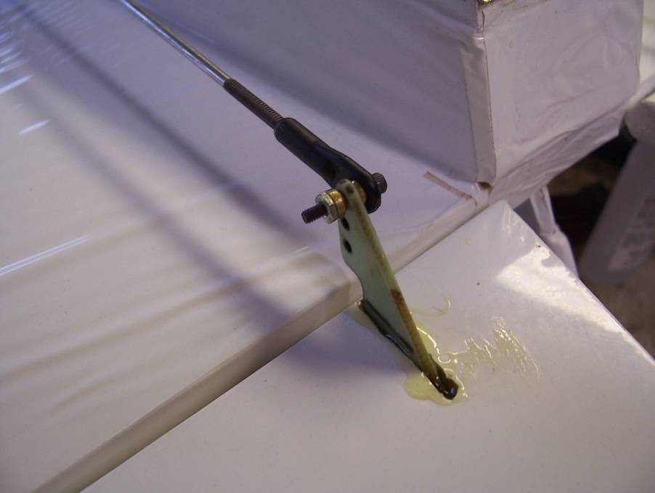

Caution make sure that the elevator control system is slop free and rigid. If this is not assured, high speed flutter of the elevators is possible, resulting in catastrophic destruction of the elevators.

As a solution to eliminate any possibility of elevator flutter, mass balancing of the elevator halves is possible. Add weight forward of the hinge line until the weight is more than the weight of the elevator. The mass balance is made of aluminum strip with the lead glued in place, secure to the elevator with two cap screws.

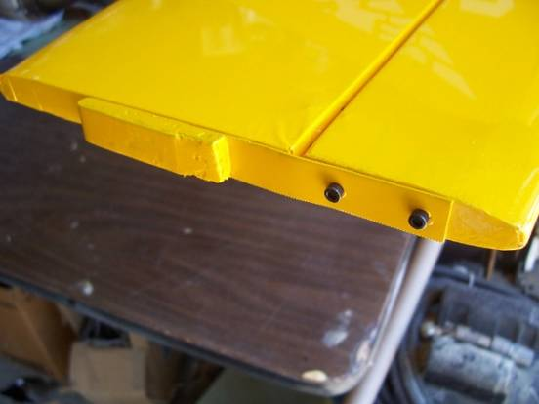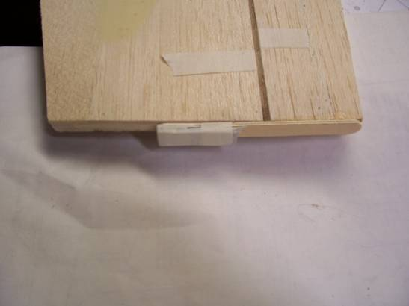
Mass balancing

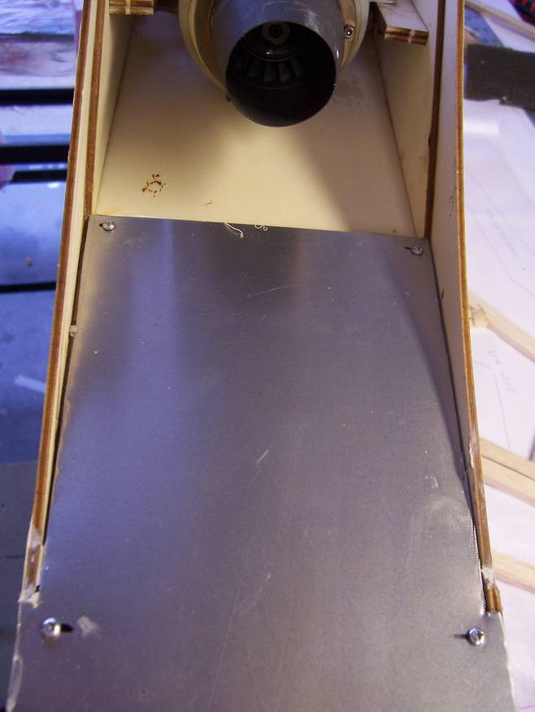
Cut the aluminum heat shield to fit inside the fuselage up to the end of the turbine, position the aluminum on the rear fuselage mark the outline of the fuselage on the aluminum, cut.
Glue the aluminum to the spacers with silicon adhesive, Note if the silicon glue squeezes out leave it till it has cured and the cut off with a sharp blade, less mess this way. Screws may be added, to secure the aluminum for security.

Retracts

Install the wheels to the retract gear, cut out the retract openings and install the retracts.
Drill and tap retract mounting holes into the retract gear supports, Tap the holes then wick C.A. into the holes, let dry and re-tap the holes.
Use 3” diameter wheels for the main, 2” for the nose wheel. Retract the gear and cut out the wheel openings in the wing and fuselage

The length of the nose gear and nose wheel needs to be adjusted so that the angle of incidence of the wing is neutral or slightly up.

Servos

The JetMach is designed to use 8 standard servos of at least 44 oz/in

Elevator 2
Rudder 1
Aileron I each
Flap 1 each.
Nose wheel 1

I used “Y”’s for the aileron and flap servos, if you choose to do this, make sure that the servo arm direction is the same for the flaps and opposite for the ailerons

Receiver

The receiver is mounted next to the nose steering servo.

Center of Gravity

C.G is 5.5” from the leading edge of the wing at the center.

Install as much of the heaviest equipment (batteries, UAT, fuel pump) as far forward as possible, this will avoid the need for adding any extra nose weight.

Control Surface Deflections

Measure at the trailing edge of the surfaces.

Maximum throws:

Aileron +/- 0.75” measured at flap
Flap - 3” measured at the center section
Elevator +/- 1.25” measured at the rear of the elevator in line with servo control arm
Rudder +/- 1.25”

Set dual rates to suit your flying style, we find that the maximum deflections shown will give smooth flying characteristics, and aerobatic capability. No exponential was used.

Flap programming

Mix approx 7% down elevator with max flap deflection to avoid pitch up with flap deflection.

Radio Installation

Receiver is located in the lower front fuselage underneath the equipment tray

72 MHz Antenna if used. Is routed through a pushrod tube down the right side of the fuselage.

Turbine Installation

The JetCat P-60 is a drop in fit for the engine mount; other turbines may/will require modification to the mount. If the mount included with your turbine is to large, make a mount with aluminum “L” section and hose clamps, (see the P-70 illustration)

Typical equipment layout

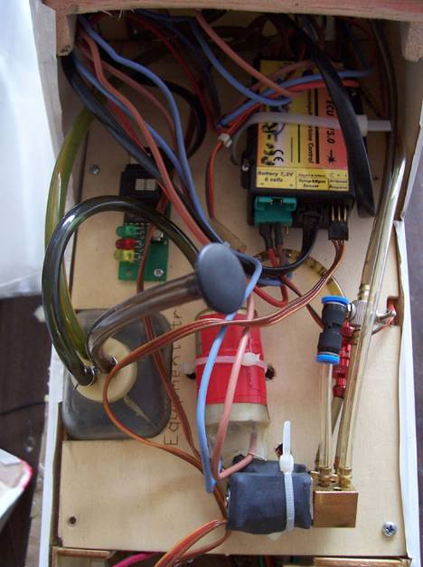

Note: A FOD screen on the turbine is highly recommended

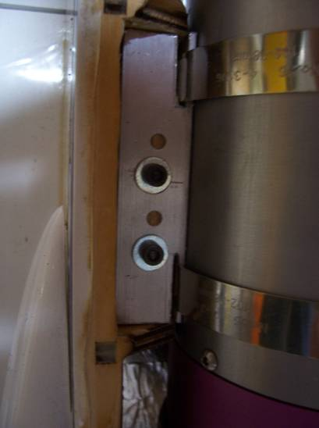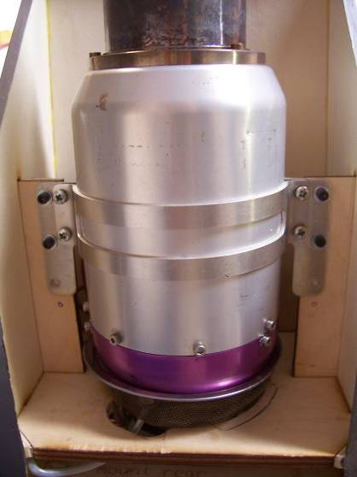
P_70 mounted on a Baby Boomerang P-60

The turbine air inlets are placed forward of the turbine
Air should be allowed to flow freely, from the intake, around the tank and to the turbine.

Flying the JetMach:

It is important to note that, although the JetMach is a airplane with stable flying qualities, it is still capable of high speed flight. You must always stay a step ahead of the plane. The plane can cover a great distance quickly.

Takeoff:

You will find takeoffs to be very simple and easy.
Make sure the nose gear is tracking straight.
Line up on the center of the runway and slowly advance the power.
The JetMach will accelerate rapidly and at times will begin to rotate on it's own after about 50ft.
On your first flight, try and keep the nose down and let the plane build up speed on the runway.
You will not need much elevator to become airborne.
Once the plane leaves the ground, you may need to hold a slight touch of DOWN elevator to keep the nose on the horizon. It will quickly gather speed and you can relax to neutral elevator. It will climb on its own.

Very short takeoff's can be accomplished by adding half flap, holding brakes on and bringing the motor up to full power. Once you reach max RPM, release the brakes and hold a touch of UP elevator. The JetMach will be airborne anywhere between 30-60ft.

Flying:

Once you established a comfortable altitude and are trimmed out, you can begin to explore the flight envelope of the JetMach. With a slight headwind and at idle power, the JetMach will fly very slowly, sometimes even appearing to fly backwards.
Stalls are exactly like you would expect. It will just slowly drop its nose and immediately begin flying again. Rolls are very axial and depending on your aileron throw, can be very fast!
Loops track straight and it is capable of very large looping maneuvers.
Slow rolls, spins, stall turns are all very easy to do. Don't be afraid to get this plane slow, it will not bite you.
I have even attempted a hovering maneuver and it almost did it, it’s all about the thrust timing. It just dropped its nose and flew out.

Knife edge flight is limited, depending on the amount of rudder throw.

Landing:

When you are ready to land, make a pass down final reducing power.
Make your turn and slowly drop in full flaps and reduce power to idle.
Make a descending turn onto final. The trick now is to watch how the plane behaves.
If you to try to level the nose and it wants’ to climb, then you still have too much speed. If you are a distance still from the runway, this is not a problem and just continue the approach trying to level the nose. Once it levels without climbing, then you are on target. It will slowly descend and decay speed all the way to the runway. It only takes a bit of up elevator to create a nice flare and a greased landing.

If on approach the plane starts getting too slow, just slowly advance power to 1/4 throttle for just a moment, then back to idle. This is good for about 200ft of ground coverage.
On a windy day, you will find that you will need a bit of throttle all the way down to the runway.

Also note that the rudder is very effective on landing. This comes in handy on crosswind days. Don't be afraid to use it. It will straighten out the nose perfectly.

The wing loading of the JetMach is low enough to allow multiple take offs and landings in one flight even with a full fuel load, great for practice, also touch and go’s are very easy.

In the event of a dead stick, just keep the nose level and manage your speed by trading altitude. Make any turns slowly and not abrupt. Only when you are sure you will make the runway, you can go ahead and add half flaps. I would not add flaps if the plane is already moving slowly when the dead stick occurred.
If it appears that you just will not be making it to the runway, add flaps if you have enough airspeed, work at keeping the wings level. Slowly begin a flare before it reaches the ground. If it does not balloon, continue adding elevator. In a full flare with full elevator, the plane should only be moving in the 15-20mph range thus lessening the chance of major damage.

Good Luck!

